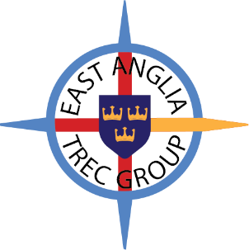
The East Anglia TREC Group will be holding our AGM on the 26th June at the Library, Forebury , Sawbridgeworth
HERTS CM21 9BD

All EATG members are invited. Come along and find out what we are planning for 2026 and meet the Committee, After the AGM , there will be a lovely selection of cakes and nibbles with tea/coffee, all who attend will get a free Raffle.

East Anglia TREC Group is also looking for new Committee members. Come and join a lively group who get involved in organising and running our events in the area. We are always grateful for anyone who wants to get involved.
Now is your chance to join the team!

If you would like to join the committee, please contact Jill Perry for a nomination form on jperry-trec@live.co.uk or to find out more phone Jill on 07984 477991. Prior to the AGM.

